SQL ASSIGNMENT 3

Customer Table

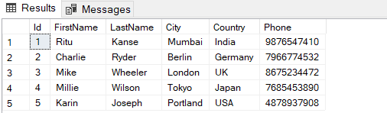

Product Table

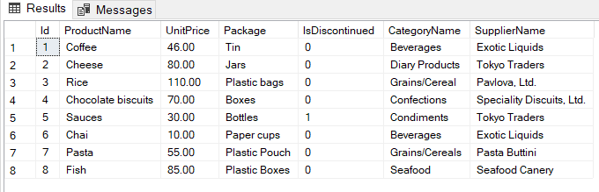

Orders Table

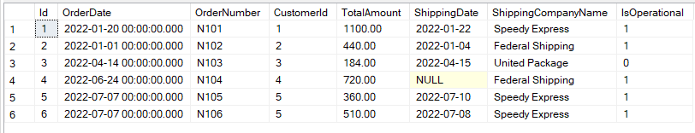

OrderItem Table

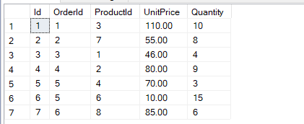

1. Write a query to display the orders placed by customer with phone number 7685453890.

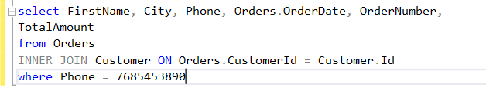

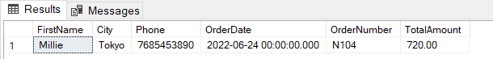

2. Fetching all the products which are available under Category ‘Seafood’.

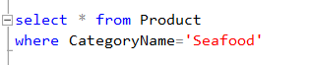

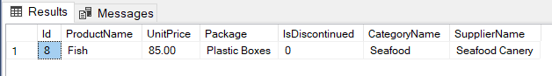

3.Display the orders placed by customers not in London

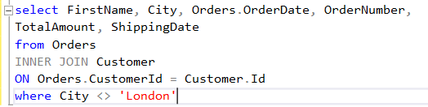

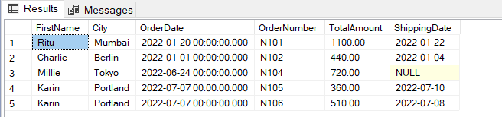

4. selects all the order which are placed for the product Chai.

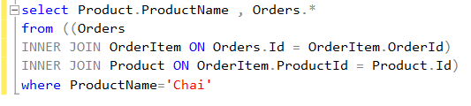

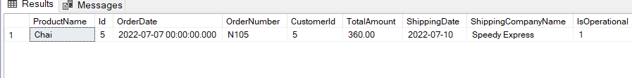

5.Write a query to display the name, department name and rating of any given employee.

select EmployeeName, DepartmentName, Ratings

from Employee

where EmployeeId=4

